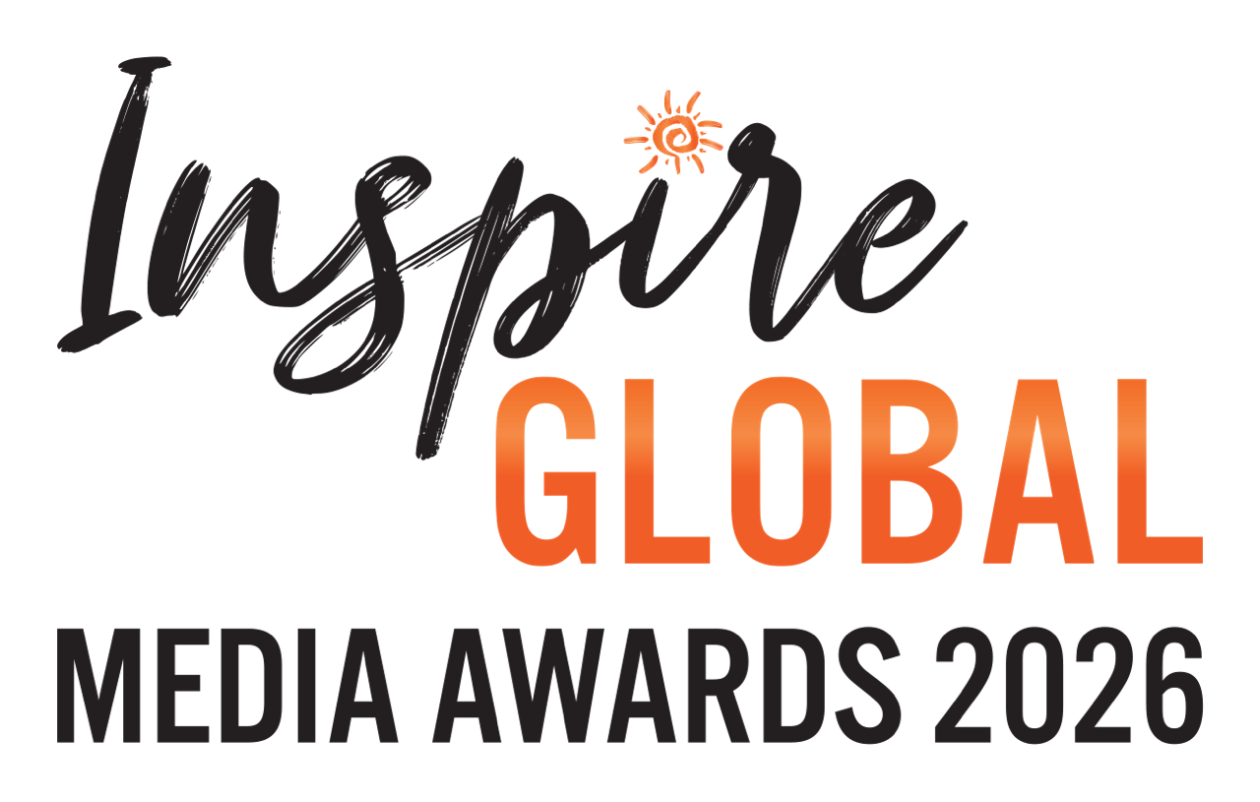

The IGMAs 2026 – SUBMISSION FORM

NAME:
EMAIL:
INSTAGRAM:
SUBSTACK:
X:
SUBMISSION(S):
Category: e.g. Consumer Feature of the Year
Region/sub-category (where applicable):
Publication: x
Feature title: x
Date published: x
Link (or attach PDF and/or images where applicable): x
COPY AND PASTE for further entries
COMMISSIONING EDITOR(S’) NAME AND EMAIL:
List in order of the above entries

CATEGORIES
Consumer Feature of the Year (UK-based writers) - 10 sub-categories - UK | Europe & North Africa | Africa & Indian Ocean | Asia | Australasia & Oceania | Middle East | North America | Latin America & Antarctica | The Caribbean | Global
Consumer Feature of the Year (International writers)
Trade Feature of the Year
Television Broadcast of the Year
Video of the Year
Podcast / Audio Programme of the Year
Travel Book of the Year
Travel Guide of the Year
Blog Story of the Year
Vlog of the Year
Short-Reel of the Year
Photo of the Year (commissioned) – 2 sub-categories – People/Community Wildlife/Environment
Photo of the Year (self-published) – 2 sub-categories – People/Community Wildlife/Environment

Please email completed submission form to Byron Shirto at info@inspireglobal.travel.

