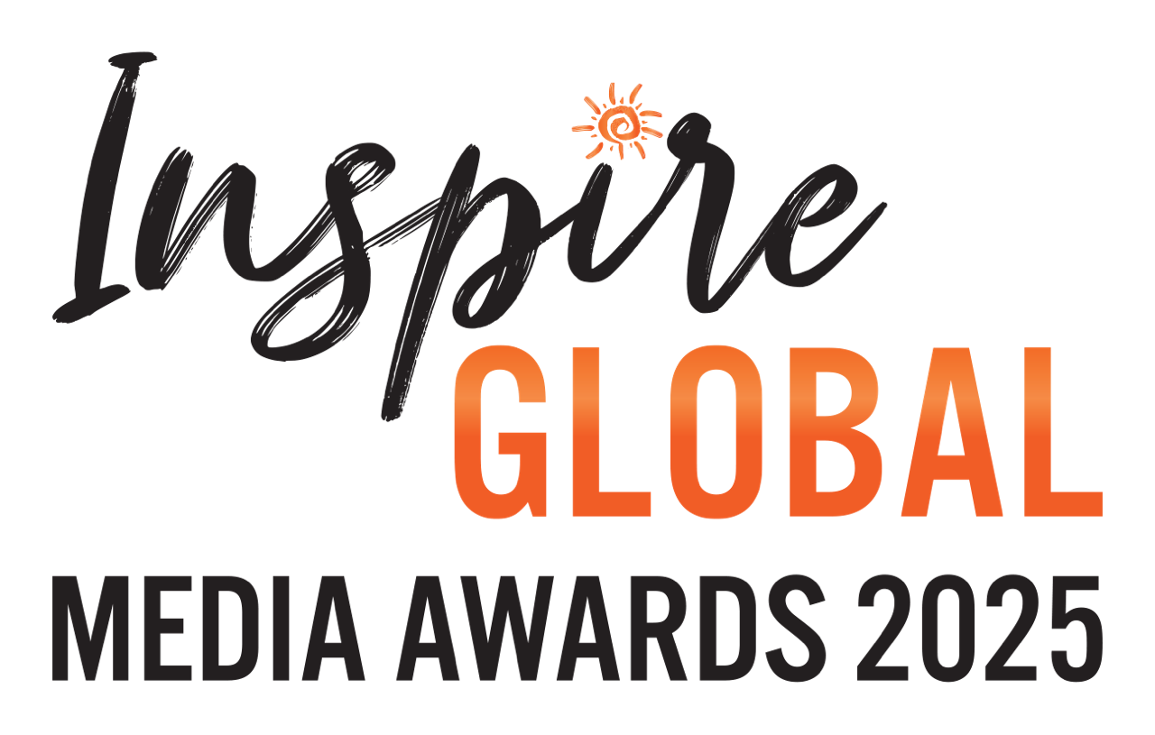

**The IGMAs 2025 – SUBMISSION FORM**

Your name:

Contact email address:

Instagram Handle:

Twitter Handle:

Number of entries to be submitted:

List publications / platforms entry / entries appeared:

List commissioning Editors name and email:

If applicable, Positive Impact Storyteller of the Year nomination and in your own words why you / they deserve the recognition:

**Please highlight the category and/or categories you are submitting in.**

**CATEGORIES**

**CONSUMER**

**Newspaper Feature of the Year (print/online)**

* UK & Europe | Africa & Indian Ocean | Asia, Australasia & Oceania |Americas & The Caribbean | Global

**Magazine Feature of the Year (print/online)**

* UK & Europe | Africa & Indian Ocean | Asia, Australasia & Oceania |Americas & The Caribbean | Global

**Online Feature of the Year**

* UK & Europe | Africa & Indian Ocean | Asia, Australasia & Oceania |Americas & The Caribbean | Global

**Blog Story of the Year**

* UK & Europe | Rest of the World | Global

**Broadcast of the Year (Vlog / Podcast)**

* UK & Europe | Rest of the World | Global

**Broadcast of the Year (Television)**

* Global

**Travel Book of the Year**

* Global

**Photo of the Year**

* People / Community | Wildlife / Environment

**TRADE**

**Trade Feature of the Year (print/online)**

* UK & Europe | Rest of the World

Please email your submission to Byron Shirto at [info@inspireglobal.travel](mailto:info@inspireglobal.travel). A member of our team will be in touch in due course.