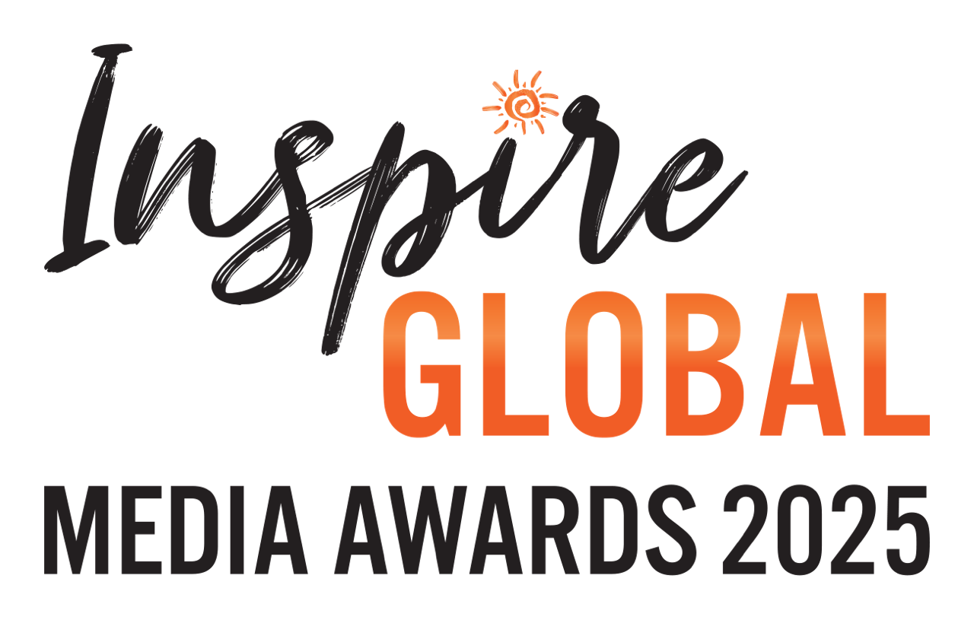

The IGMAs 2025 – SUBMISSION FORM

NAME:
EMAIL:
INSTAGRAM:
TWITTER:
TOTAL NUMBER OF ENTRIES SUBMITTED: X
SUBMISSION(S):
Category: e.g. Consumer - Online Feature of the Year
Region/sub-category: X
Publication: X
Feature title: X
Date published: X
Link (or attach PDF): X
COPY AND PASTE for further entries
Don’t forget to highlight the categories you’re entering on next page
COMMISSIONING EDITOR(S’) NAME AND EMAIL:
List in order of the above entries
POSITIVE IMPACT STORYTELLER OF THE YEAR
If applicable, Positive Impact Storyteller of the Year nomination and in your own words why you / they deserve the recognition:

Please highlight the category and/or categories you are submitting in.
CATEGORIES
CONSUMER
Newspaper Feature of the Year (print/online)
- UK & Europe | Africa & Indian Ocean | Asia, Australasia & Oceania |Americas & The Caribbean | Global
Magazine Feature of the Year (print/online)
- UK & Europe | Africa & Indian Ocean | Asia, Australasia & Oceania |Americas & The Caribbean | Global
Online Feature of the Year
- UK & Europe | Africa & Indian Ocean | Asia, Australasia & Oceania |Americas & The Caribbean | Global
Blog Story of the Year
- UK & Europe | Rest of the World | Global
Broadcast of the Year (Vlog / Podcast)
- UK & Europe | Rest of the World | Global
Broadcast of the Year (Television)
- Global
Travel Book of the Year
- Global
Photo of the Year
- People / Community | Wildlife / Environment
TRADE
Trade Feature of the Year (print/online)
- UK & Europe | Rest of the World
Please email completed submission form to Byron Shirto at info@inspireglobal.travel.

